Twitter at the European Elections 2014:
One-Day Symposium (French & English speaking)
Université de Lorraine à Metz, le 5 février 2015
Programme:
9h00 Participants arrive / Accueil (Université de Lorraine, ile du Saulcy, salle Ferrari)
9h30 Presentations :
- Dario Compagno, Univ. Lorraine: “Families of practices. Employing data mining techniques to differentiate how French candidates make use of Twitter”.
- Eric Leclercq, Marinette Savonnet, Univ. Bourgogne, Sergey Kirgizov, Lobna Azaza: "A typology of algorithms for social network analysis: results from experiments - towards a toolbox for social scientist"
- Arnaud Mercier, Univ. Lorraine & Marina Villa, UniCatt (Milan): "The figure of the enemy during the 2014 European tweet-campaign in France and Italy"
- Nanta Novello Paglianti, Univ. Franche-Comté: "Political communication during the 2014 European elections in Italy: uses of Twitter by two candidates of the list Tsipras"
- Marina Villa, UniCatt (Milan): "Twitter and double screen in Italy during the 2014 European elections "
- Elena Cebrian Guinovart, CEU Madrid: “Same old song: approaching the Twitter European campaign of the new party Podemos”
12h30 - 14h Lunch / pause déjeuner
14h - 16h30 Presentations:
- Tatiana Kondrashova & Alex Frame, Univ. Bourgogne: “Exploring the dialogical dimension of political tweets: A qualitative analysis of ‘Twitter styles’ of UK candidates during the 2014 EU Parliamentary Elections”
- Elena Albu, Univ. Genève: “Twitter use during European Elections: the case of the UKIP candidates”
- Sandrine Roginsky, UCL: “What tweets say about their authors? Triangulation of methods to analyse Twitter use by candidates in the run up to the EP elections. The case of UK candidates in the Yorkshire and the Humber constituency”
- Caja Thimm, Jessica Einspänner Pflock & Laurent Gautier, Bonn University & Univ. Bourgogne: “German political communication on Twitter during the 2014 European Elections”
- Evelien D’heer & Pieter Verdegem, MICT – Ghent University, “Who covers Belgian candidates running for the 2014 EU elections? A Twitter perspective on European political communication”

16h30 : Discussion with MEP / dialogue avec Nathalie Griesbeck, @Nat_GRIESBECK, eurodéputée, about her political & electoral uses of Twitter.
17h30 – 18h30 : General debate & conclusions / débat sur le bilan global et comparé des présentations
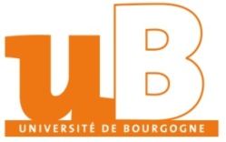
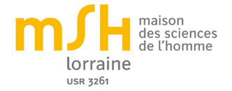
Workshop organisé dans le cadre du projet interMSH « Twitter aux élections européennes » soutenu par :

